CCENT ICND 100-105
TL Chp 1

MULTIPLE CHOICE

1. Look at the following device by default how many collision and broadcast domains does it have?

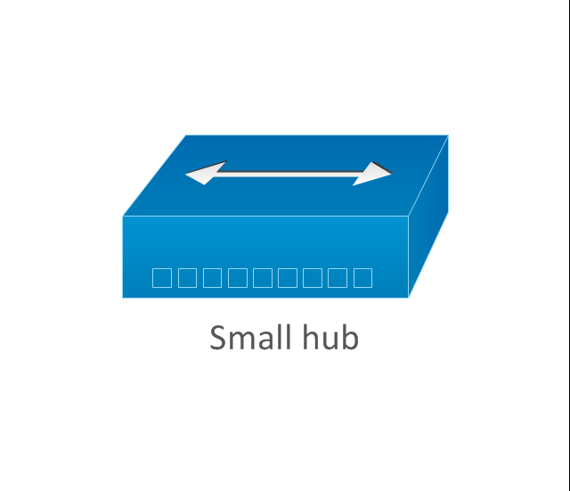
a. | it includes 1 collision domain and 1 broadcast domain | c. | It includes 2 collision domains and 2 broadcast domains
b. | Int includes 8 collision domains and 8 broadcast domains | d. | It includes 10 collision domains and no broadcast domains

ANS: A

2. When we use the OSI model, which of the following is a true statement about its’ PDU
a. | A segment contains IP addresses | c. | A segment contains MAC addresses
b. | A packet contains IP address | d. | A packet contains MAC addresses

ANS: B

3. The Executive department computers will be assigned IP addresses ranging from 192.168.100.1 - 192.168.100.100 using a 24-bit mask. The HR department will be assigned IP addresses ranging from 192.168.101.1 – 192.168.101.100 What type of device will be needed to have both groups share information?
a. | Hub | c. | Router
b. | Switch | d. | Bridge

ANS: C

4. What Device would reduce congestion on a Lan?
a. | Upgrade the network cards | c. | Replace Hubs with Switches
b. | Change the cabling to CAT6 | d. | Upgrade the CPUs in the routers

ANS: C

5. You need to create a network that would hold 200 nodes. You must ensure that they have full-duplex capabilities. What device would do that at Layer 2 of the OSI model?
a. | Hub | c. | Router
b. | Switch | d. | Bridge

ANS: B

6. Which layer of the OSI model is responsible for checking the availability of the receiving program and checking to see if enough resources are available for communication?
a. | Transport | c. | Presentation
b. | Network | d. | Application

ANS: D

7. Which layer of the OSI model is subdivided into two layers?
a. | Presentation | c. | Data Link
b. | Transport | d. | Physical

ANS: C

8. A __________ is an example of a device that belongs on the physical layer of the OSI Model.
a. | Hub | c. | Router
b. | Switch | d. | Bridge

ANS: A

9. Which of the following is not a benefit of using a reference model?
a. | It divides the network communication process into smaller and simpler components. | c. | It enforces consistency across vendors
b. | It encourages industry standardization | d. | It allows various types of network hardware and software to communicate

ANS: C

10. What answer is not true about routers?
a. | They forward broadcast by default | c. | They perform path selection
b. | They can filter the network based on Network layer information | d. | They perform packet switching

ANS: A

11. Switches by default break up _____ domains, and routers by default brake up ______ domains.
a. | broadcast, broadcast | c. | collision, broadcast
b. | collision, collision | d. | broadcast, collision

ANS: C

12. What device operates at all layers of the OSI model?
a. | Network Host | c. | Router
b. | Switch | d. | Bridge

ANS: A

